CO2 Concentrations In Mauna Loa And How The Trend Impacts Our World

Ryan Meadows

Dec 14, 2022

Honors Trigonometry Pre-Calculus

Mr. Koutahi

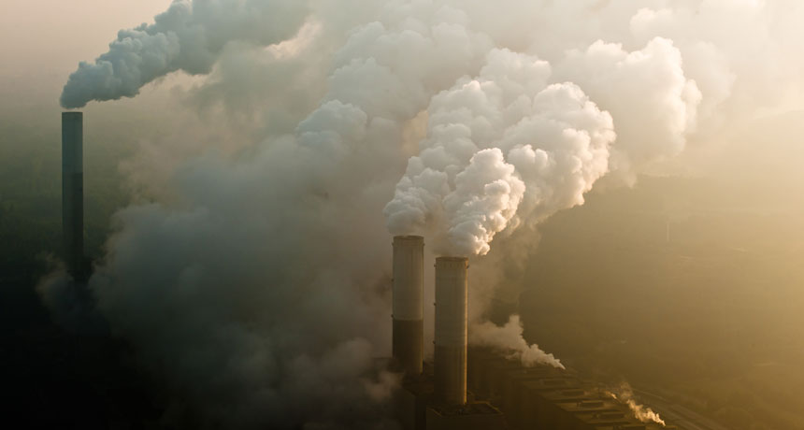

Wilke, C. (2019, November 4). *CO2 emissions are on track to take us beyond 1.5 degrees of global warming*. Science News. Retrieved December 11, 2022, from https://www.sciencenews.org/article/co2-emissions-global-warming

**Abstract**

CO2 concentrations have become a large issue in our world today. They influence global politics and determine the future of our world. One of the greatest tests of humanity is how we handle this issue. In this report I will analyze the CO2 concentrations measured in Mauna Loa and use the knowledge I have gained from Trigonometry Pre-Calculus to analyze the past data and then predict some possible outcomes in the next few years.

The first step in understanding the data was to make a scatter plot with the available data. In the following figure 0 on the X axis represents the year 1960.

At first glance this data looks linear. However, after testing various lines of best fit, I have determined that the data is quadratic. I will include all the Lines of best fit and their R² values. The R² value represents how close the line is to matching the data, a perfect match would be a value of 1.

Linear:

y = 1.6279x + 308.36  
R² = 0.9834

Linear was my first guess based on a quick glance but after inserting the different lines of best fit I can see that this is not the best option.

Quadratic:

y = 0.013x2 + 0.836x + 316.27  
R² = 0.9994

The quadratic line of best fit does seem superior compared to the others. Visually it fits the best, however it also has the highest R² value making it the best option.

Exponential:

y = 310.84e0.0045x  
R² = 0.9912

The exponential line of best fit is better than the linear one however it fails to model the beginning or the end of the graph effectively.

Up to this point the data we have analyzed only tells part of the story of CO2 concentrations. Each data point on that graph was collected in January but the levels fluctuated throughout the year. In April the ppm, parts per million of CO2 is 2.5 higher than the average in January, and in October the values are about 2.5 ppm below those of January.

After creating a new table that factors in these quarterly oscillations our graph looks like this.

To understand this new model mathematically we can just look at one year. In this case the year 1960 – 1961.

As you can see over the seasons, we have a sine wave. The shifts are caused by the growth and decay of vegetation in the northern part of the world. This could look like trees, algae, and other growth that die and regrow over the seasons. This happens specifically in the northern regions because they get extremely cold during their winter and stop processing the CO2 during their winter season, while the southern hemisphere does this during its whole cycle in many areas.

Links:

https://www.amnh.org/exhibitions/climate-change/changing-atmosphere/the-ups-and-downs-of-co2

<https://svs.gsfc.nasa.gov/4565>

Ciations:

NASA. (2017, May 4). *SVS: Seasonal changes in carbon dioxide*. NASA. Retrieved December 7, 2022, from https://svs.gsfc.nasa.gov/4565

*The ups and downs of CO2: AMNH*. American Museum of Natural History. (n.d.). Retrieved December 7, 2022, from https://www.amnh.org/exhibitions/climate-change/changing-atmosphere/the-ups-and-downs-of-co2

We can create an equation to represent this wave by taking various pieces of information from the graph and putting them into the format $y=a*\sin\left(bx+c\right)+d$.

The first thing to determine is the amplitude and the “a” value of our equation.

To get the amplitude I subtracted the Minimum value from the maximum then divided that by two. This is also the maximum distance from the average value.

The curve is increasing after the Y axis of the graph. This means that the “a” value will be positive. In this case the amplitude is +2.5.

The next variables are our period and “b” value. To determine the period graphically I will measure the distance between every other zero / average value of the graph. In this case the period Is one year.

The b value is found with the equation: 🡪 🡪

Now that we have this information, we can put this all together and make the final equation. There is no phase shift in the equation, so I don’t have to worry about that part. The base equation for a sine wave is y=a*sin(bx+c)+d. We don’t have a “c” value so we can just remove that part. I will substitute the “a” value I found doing the amplitude and the “b” value found solving for the period. The d value is the average value or the initial value for the year.

Our final equation looks like: $$y=2.5\sin\left(2πx\right)+317$$

The issue with this equation is that it doesn’t represent the whole picture, rather it only shows one year. We know that the concentrations increase each year while it oscillates through the seasons. We can show that by replacing the “d” value in the one-year equation with the quadratic equation from earlier. After you combine these the equation looks like this.

0.013x2 + 0.836x + 316.27

Looking back at the graph we can see how this equation relates to the data.

Now that we have this formula, we can predict with varying accuracy the CO2 concentrations in future years. y = 0.013x2 + 0.836x + 316.27 This model will find the average level at the beginning of the year.  
I just need to input the date in terms of years since 1960. For 2022 this will be 2022-1960=62. I substitute the values and get y = 0.013(62)2 + 0.836(62) + 316.27 which gives me y = 418.074 (ppm). I repeat these steps for 2032 and 2042 getting the following results.

CO2 (in ppm) for 2032:

72 years --- gives me y = 443.854(ppm)

CO2 (in ppm) for 2042:

82 years --- returns y = 472.234(ppm)

**Conclusion**

CO2 is the most prevalent greenhouse gas in the atmosphere radiating heat back to the earth. In the right amounts this gas keeps the earth from freezing and at a stable temperature for life. However, humans have artificially inflated the concentrations as you can see in the data. Due to this the global average temperature is rising. This warming is altering many animals and plants across the globe and damaging carefully balanced Ecosystems.

Due to global warming some plants bloom earlier which extends traditional growing seasons. This is an issue because seasonal shifts can become more dramatic with longer plant growth seasons (Copernicus). This can be seen as the teeth or smaller waves in the graph having a larger amplitude over time.

Links:

https://www.climate.gov/news-features/understanding-climate/climate-change-atmospheric-carbon-dioxide#:~:text=Without%20carbon%20dioxide%2C%20Earth's%20natural,causing%20global%20temperature%20to%20rise.

https://atmosphere.copernicus.eu/carbon-dioxide-levels-are-rising-it-really-simple

ciations:

Lindsey, R. (2022, June 23). *Climate change: Atmospheric carbon dioxide*. NOAA Climate.gov. Retrieved December 8, 2022, from https://www.climate.gov/news-features/understanding-climate/climate-change-atmospheric-carbon-dioxide#:~:text=Without%20carbon%20dioxide%2C%20Earth's%20natural,causing%20global%20temperature%20to%20rise.

copernicus. (2019, May 28). *Carbon dioxide levels are rising: Is it really that simple?* Homepage. Retrieved December 8, 2022, from https://atmosphere.copernicus.eu/carbon-dioxide-levels-are-rising-it-really-simple

Works Cited

copernicus. (2019, May 28). *Carbon dioxide levels are rising: Is it really that simple?* Homepage. Retrieved December 8, 2022, from https://atmosphere.copernicus.eu/carbon-dioxide-levels-are-rising-it-really-simple

Environmental Protection Agency. (2022, July). *Climate Change Indicators: Atmospheric Concentrations of Greenhouse Gases*. EPA. Retrieved December 11, 2022, from https://www.epa.gov/climate-indicators/climate-change-indicators-atmospheric-concentrations-greenhouse-gases

Lindsey, R. (2022, June 23). *Climate change: Atmospheric carbon dioxide*. NOAA Climate.gov. Retrieved December 8, 2022, from https://www.climate.gov/news-features/understanding-climate/climate-change-atmospheric-carbon-dioxide#:~:text=Without%20carbon%20dioxide%2C%20Earth's%20natural,causing%20global%20temperature%20to%20rise.

NASA. (2017, May 4). *SVS: Seasonal changes in carbon dioxide*. NASA. Retrieved December 7, 2022, from https://svs.gsfc.nasa.gov/4565

*The ups and downs of CO2: AMNH*. American Museum of Natural History. (n.d.). Retrieved December 7, 2022, from https://www.amnh.org/exhibitions/climate-change/changing-atmosphere/the-ups-and-downs-of-co2

Wilke, C. (2019, November 4). *CO2 emissions are on track to take us beyond 1.5 degrees of global warming*. Science News. Retrieved December 11, 2022, from https://www.sciencenews.org/article/co2-emissions-global-warming